Name: PRATIK SUNIL ABHANG
Registration ID: 260640160209

Question
Q1
Navigate to the Scripts directory using an absolute path.

Command(s)
cd /home/<Username>/Documents/Linux/Scripts

Output
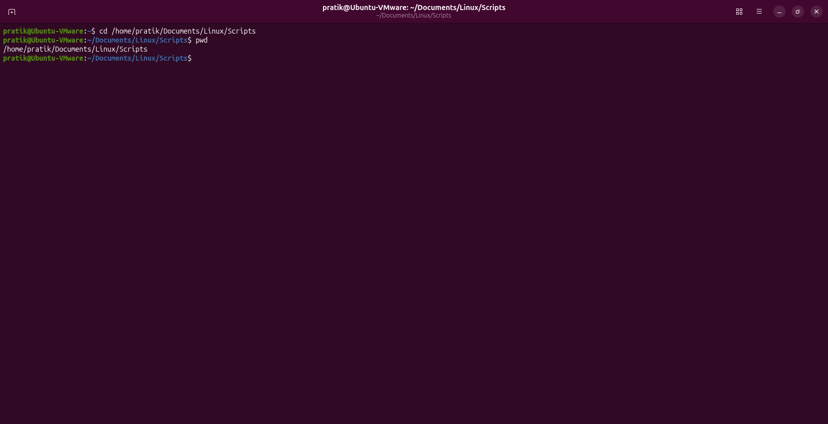

Question
Q2
Navigate to the Projects directory using a relative path.

Command(s)
cd Documents/Projects

Output
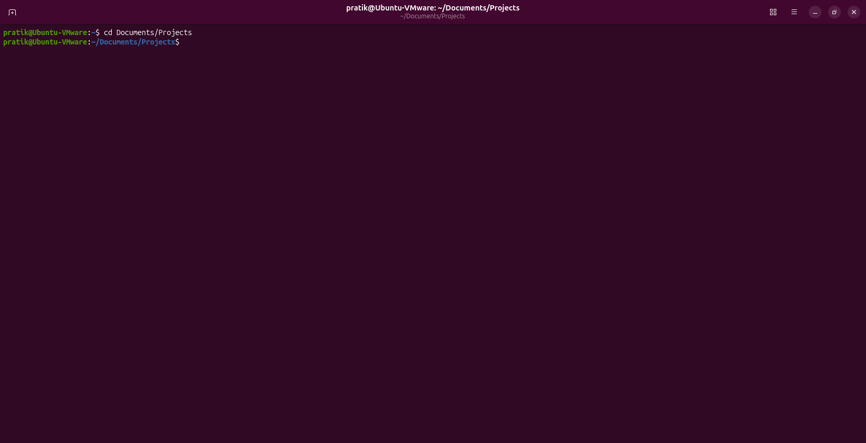

Question
Q3
From Notes navigate to Downloads using a relative path.

Command(s)
cd ../../../Downloads

Output
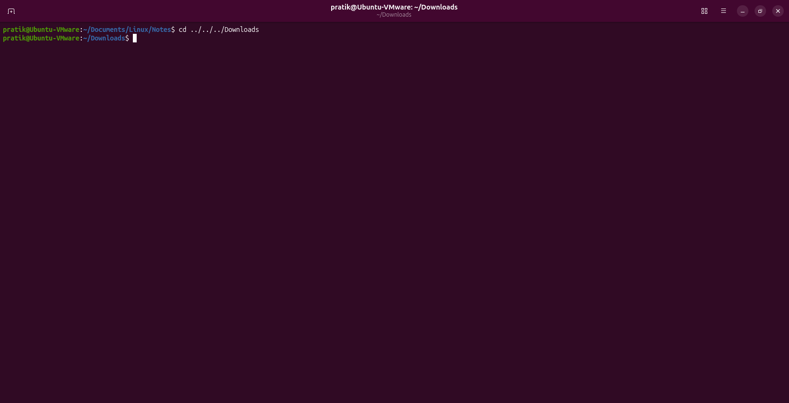

Question
Q4
From Scripts go back to home using the shortest command.

Command(s)
cd

Output


Question
Q5
From Projects navigate to Notes using a relative path.

Command(s)
cd ../Linux/Notes

Output


Question
Q6
Go to Pictures and display current working directory.

Command(s)
cd /home/<Username>/Pictures
pwd

Output
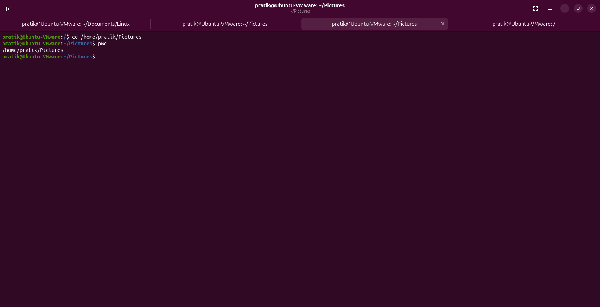

Question
Q7
Move to the root directory and verify your location.

Command(s)
cd /
pwd

Output
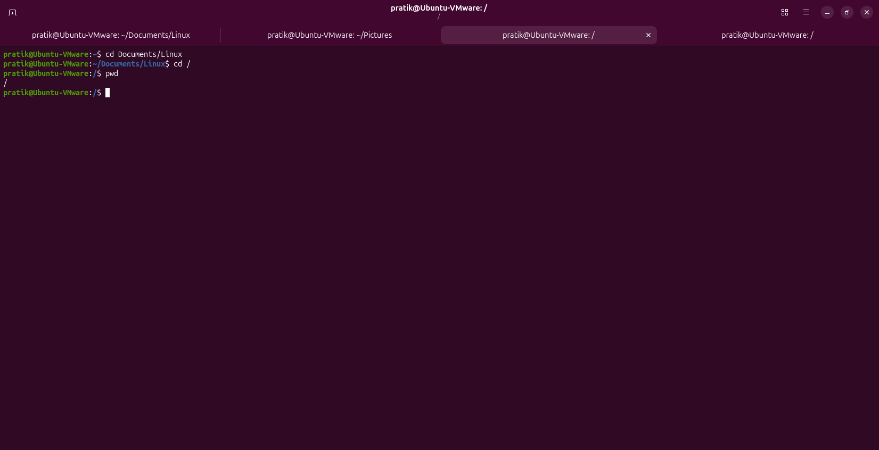

Question
Q8
List Downloads using an absolute path without changing directory.

Command(s)
ls /home/<Username>/Downloads

Output
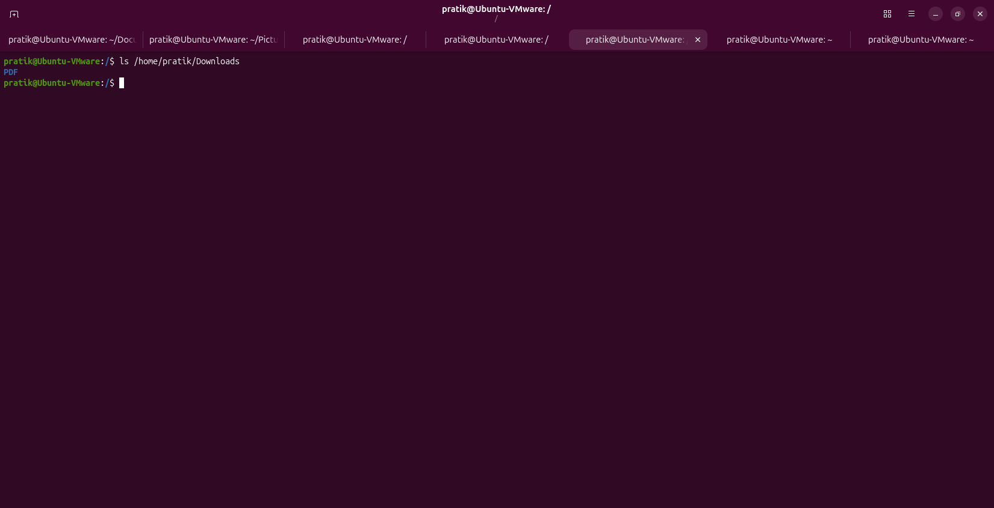

Question
Q9
From Notes navigate to Music using a relative path.

Command(s)
cd ../../../Music

Output
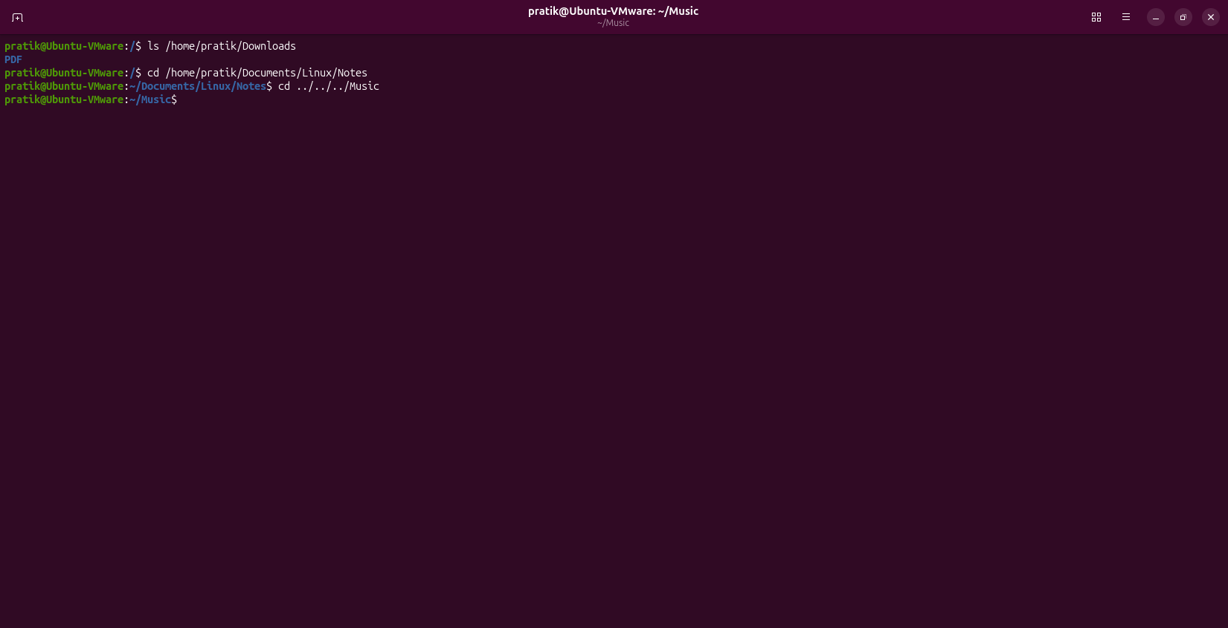

Question
Q10
Sequence: Linux -> parent -> Projects -> home.

Command(s)
cd Documents/Linux
cd ..
cd Projects
cd

Output
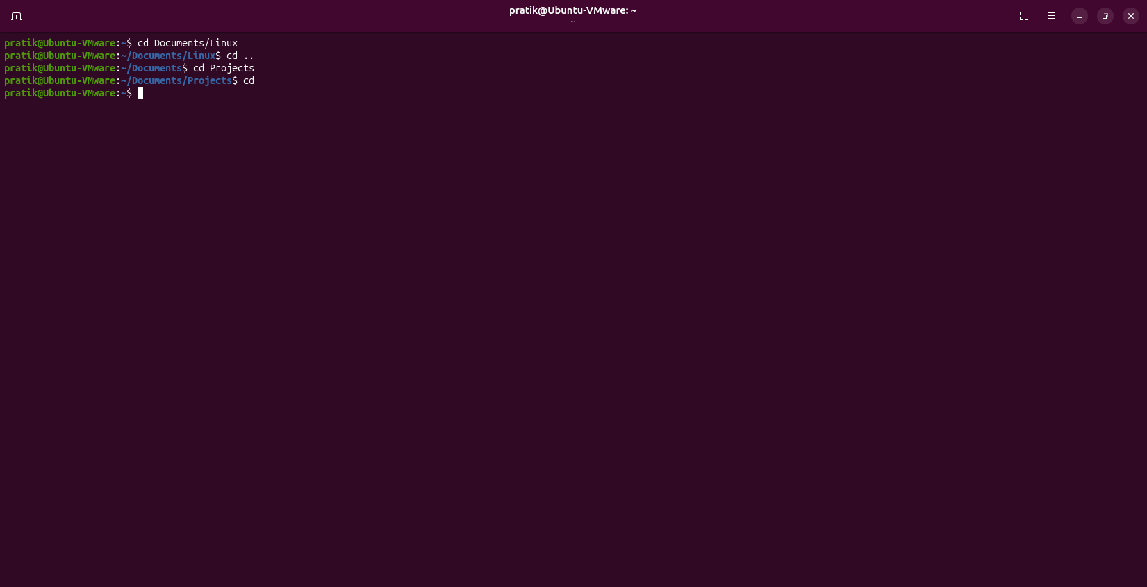

Question
Q11
Navigate to Documents, display employees.txt and find IT employees.

Command(s)
cd Documents
cat employees.txt
grep "IT" employees.txt

Output
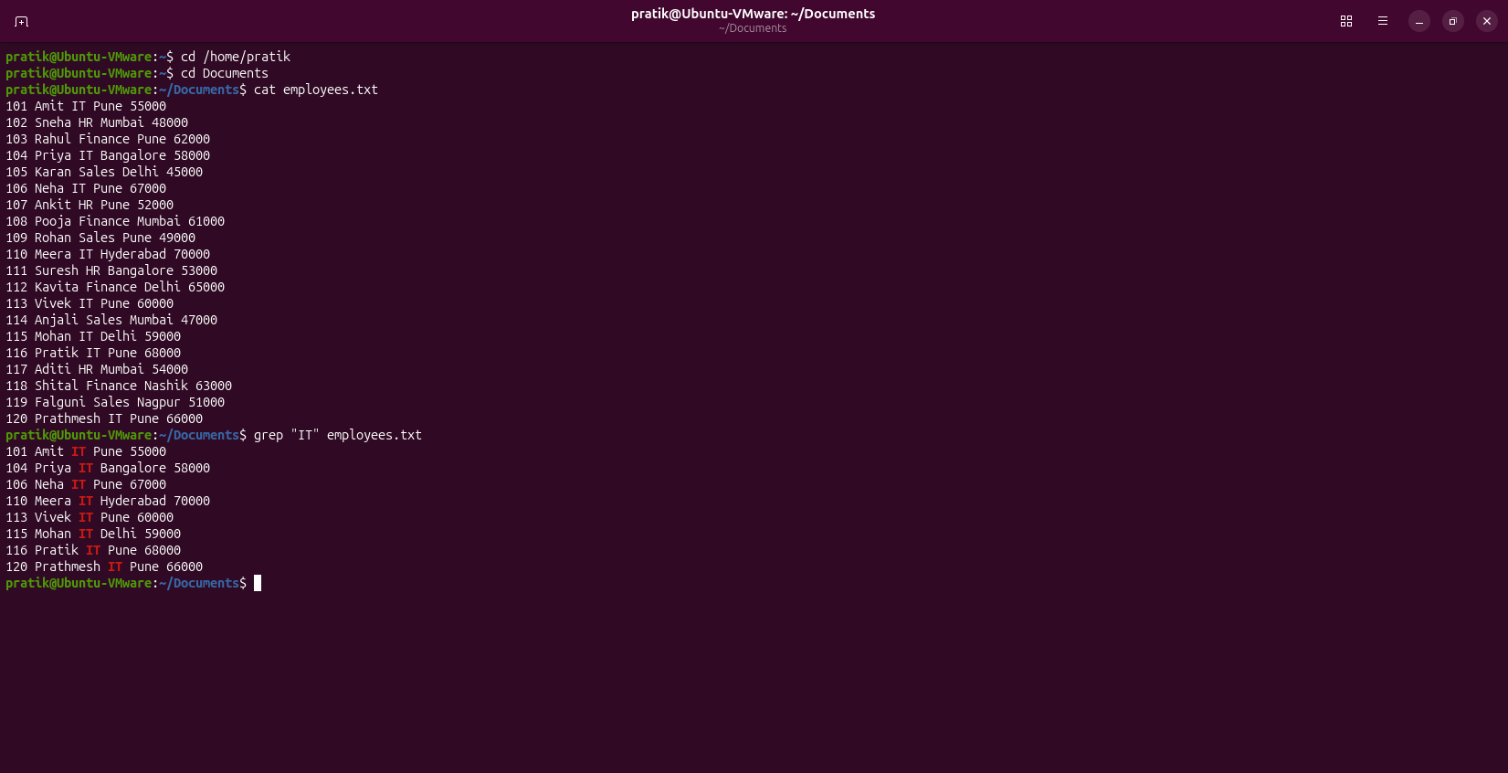

Question
Q12
Display HOME, navigate using HOME variable and list all files.

Command(s)
echo $HOME
cd $HOME
ls -la

Output
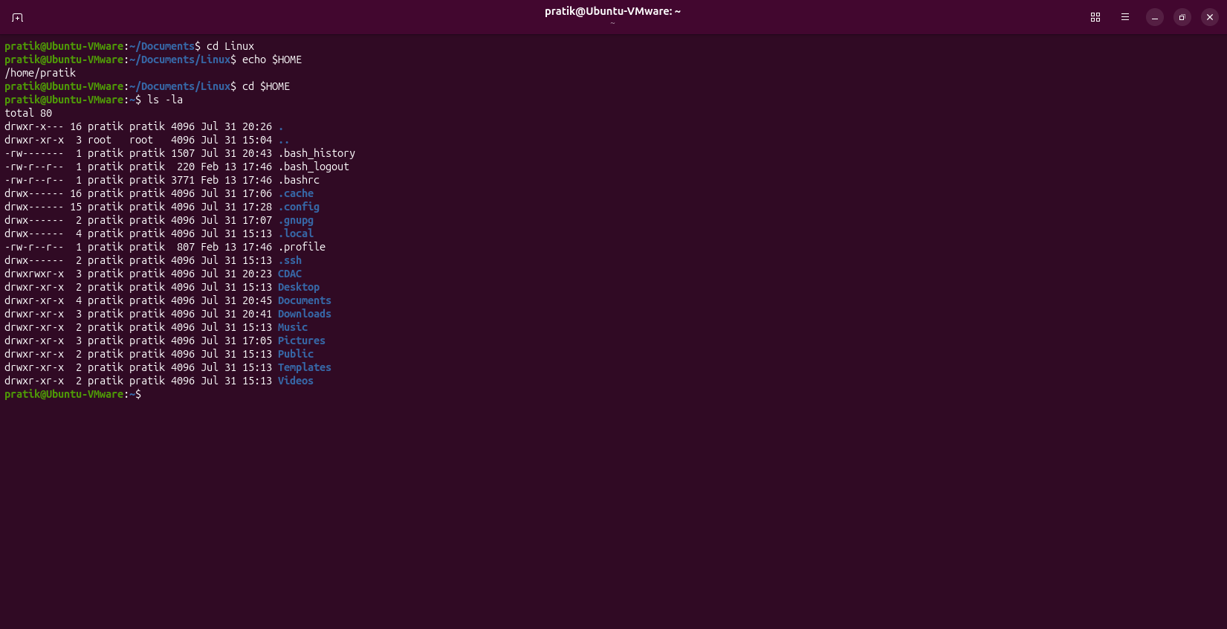

Question
Q13
List Linux directory, search 'server' in config.txt with line numbers.

Command(s)
cd /home/student/Documents/Linux
grep -n "server" /home/student/Documents/Linux/config.txt

Output
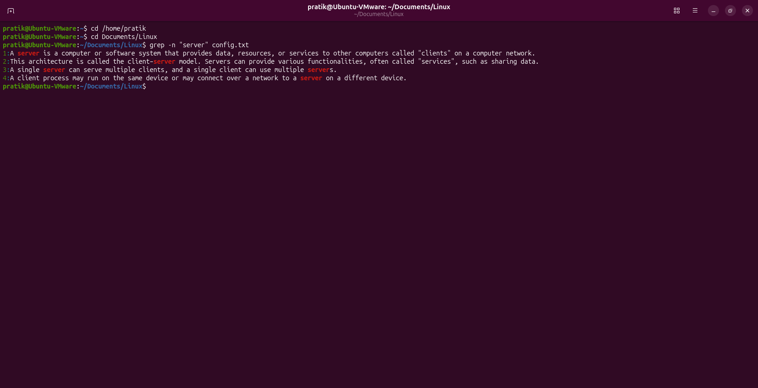

Question
Q14
Combine navigation, listing and searching.

Command(s)
cd Documents/Linux
ls -la
grep "IT" ../employees.txt

Output
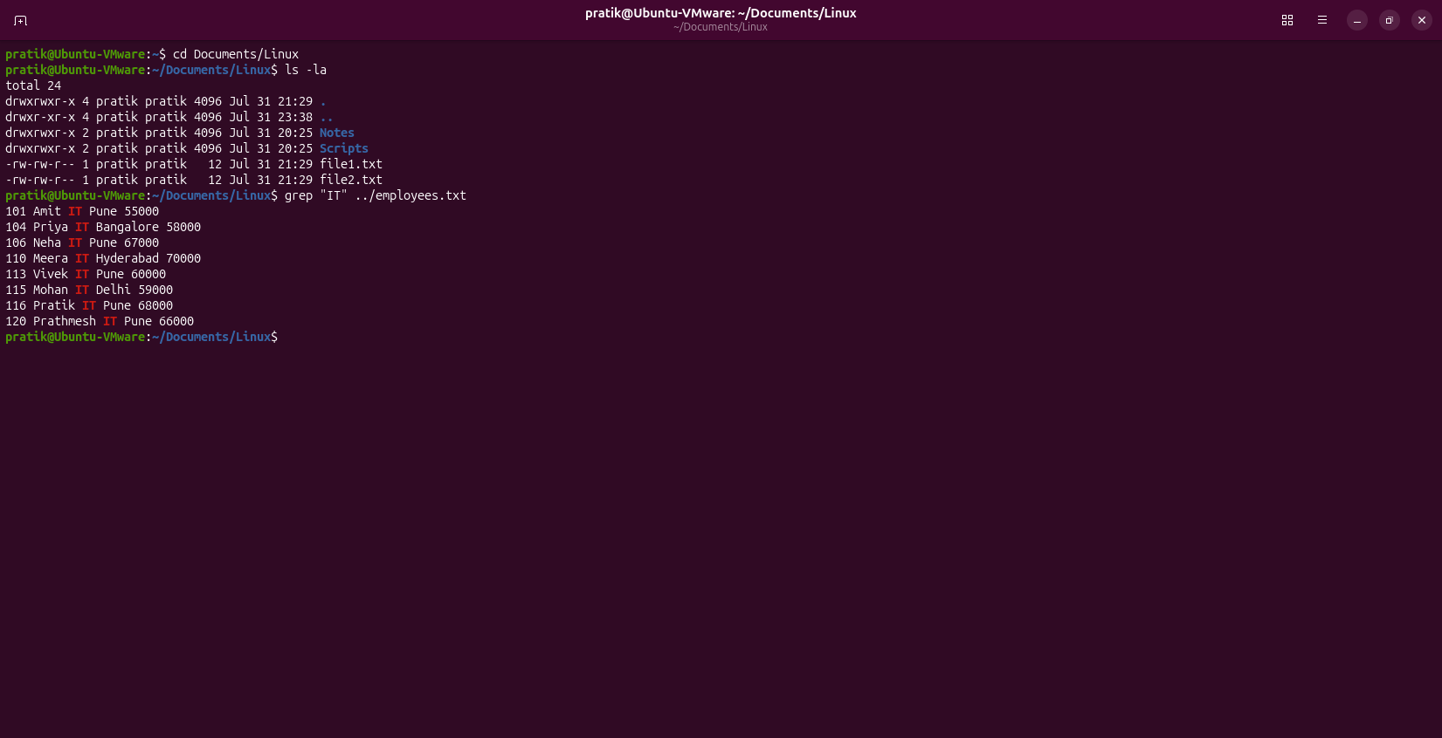

Question
Q15
Environment variables, HOME variable, list home directory and display .bashrc.

Command(s)
env
echo $HOME
ls
cat ~/.bashrc

Output
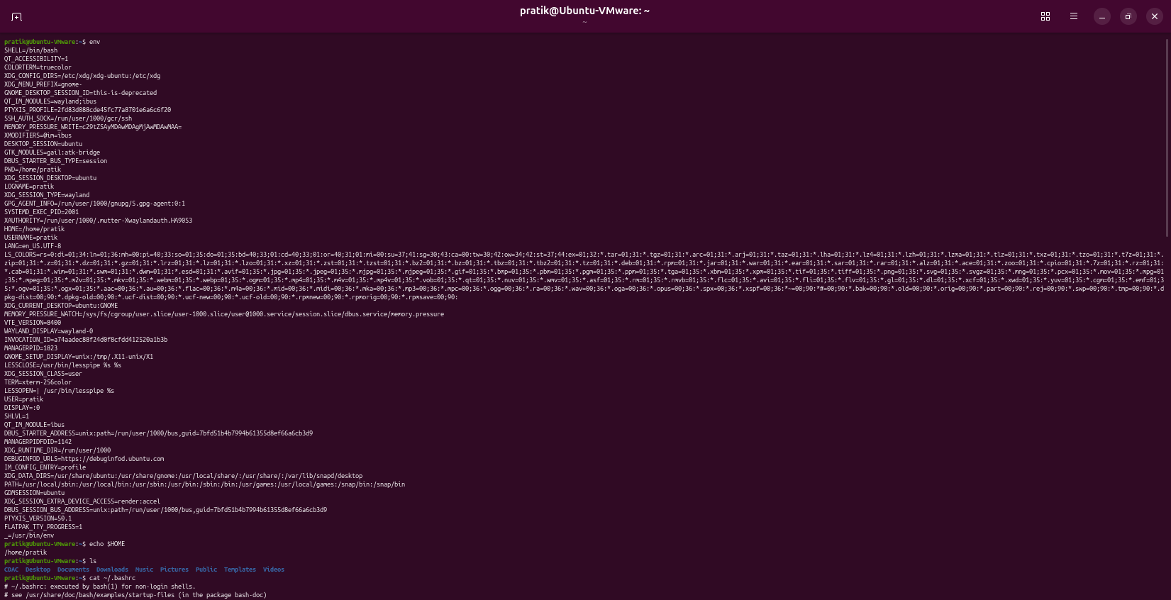

Question
Q16
Print the output of last 9th command executed.

Command(s)
!-9

Output
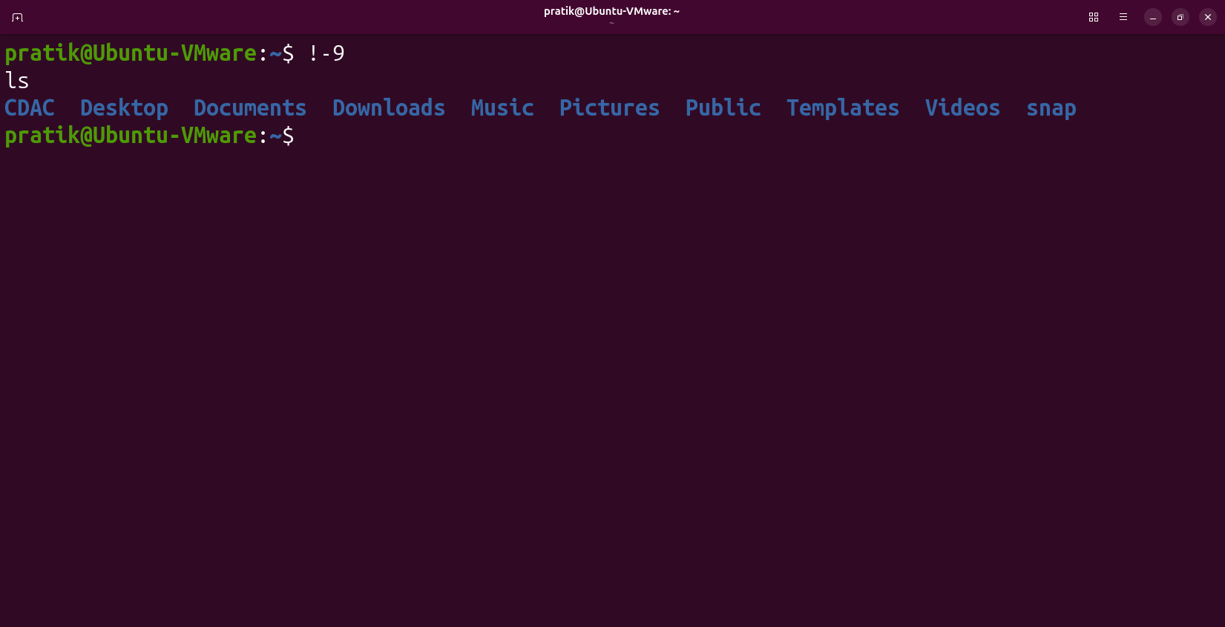

Question
Q17
Print the output of the last command executed.

Command(s)
!!

Output
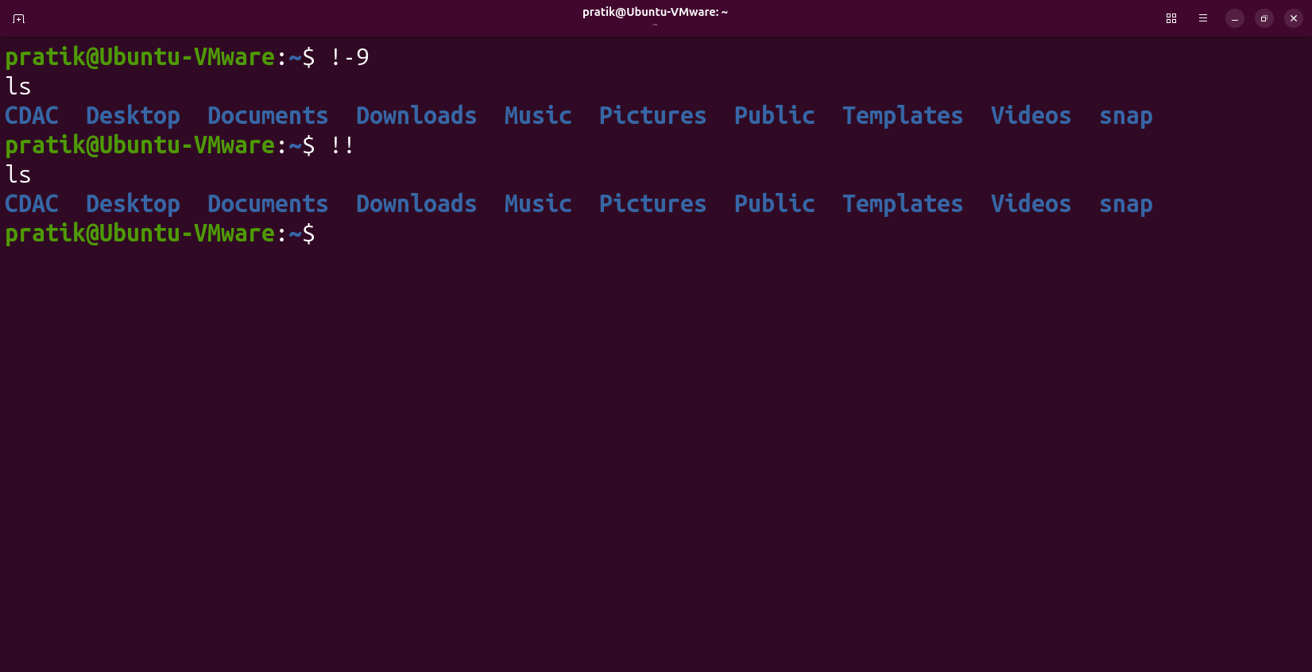

Question
Q18
Write a short note on SSH service and Ubuntu configuration.

Command(s)
Commands:
sudo apt update
sudo apt install openssh-server
sudo systemctl enable ssh
sudo systemctl start ssh
sudo systemctl status ssh
SSH Clients:
ssh (Linux), PuTTY, OpenSSH, MobaXterm, Bitvise SSH Client

Answer
SSH (Secure Shell) is a secure network protocol used to remotely access and administer systems over an encrypted connection. It provides secure login, remote command execution, secure file transfer (SCP/SFTP), and tunneling. Ubuntu can be configured by installing the OpenSSH server, enabling and starting the ssh service, and connecting using an SSH client.

